"Model of the combined power supply system in MatLab/Simulink "
Purpose: modeling of the solar panel with the necessary elements, as part of the energy supply system of the housing facility. Analysis of data obtained as a result of work.
Basic statements
Power supply system in the composition of which there is such an element as a solar panel, should have additional elements of the system for its normal functioning. Therefore, this model should include the following blocks: the solar panel; battery; consumer and controller, which actually will manage this system.
With the help of this model, it is possible to analyze and obtain data on the generation of electricity by solar panels while changing the original data that will be relevant for a specific locality. As a result, you can see the general picture of the generation of solar energy, analyze its feasibility in specific conditions and use it for further calculations.
The order of performance of work
- Modeling of the solar panel.
The PV block is a standard Simulink block and has two inputs:
- Ir values ​​of solar radiation, W / m 2 ;
- T value of temperature at the time of measurement, C.
Values ​​of these values ​​can be found at: http://re.jrc.ec.europa.eu/pvg_tools/en/tools.html
To download the data you need to select the land of interest and in the hourly values ( Hours Data ) section set the required values ​​and tick the radiation . (For example, Germany was chosen, the data was used for 2016, and the installed panel thickness is 2.5 kW)
After loading the received values, enter them in MatLab as a data matrix for further work with them. In this case, you need to enter data from the columns where the values ​​of solar radiation and temperature are located by specifying their respective row and column in the command line.
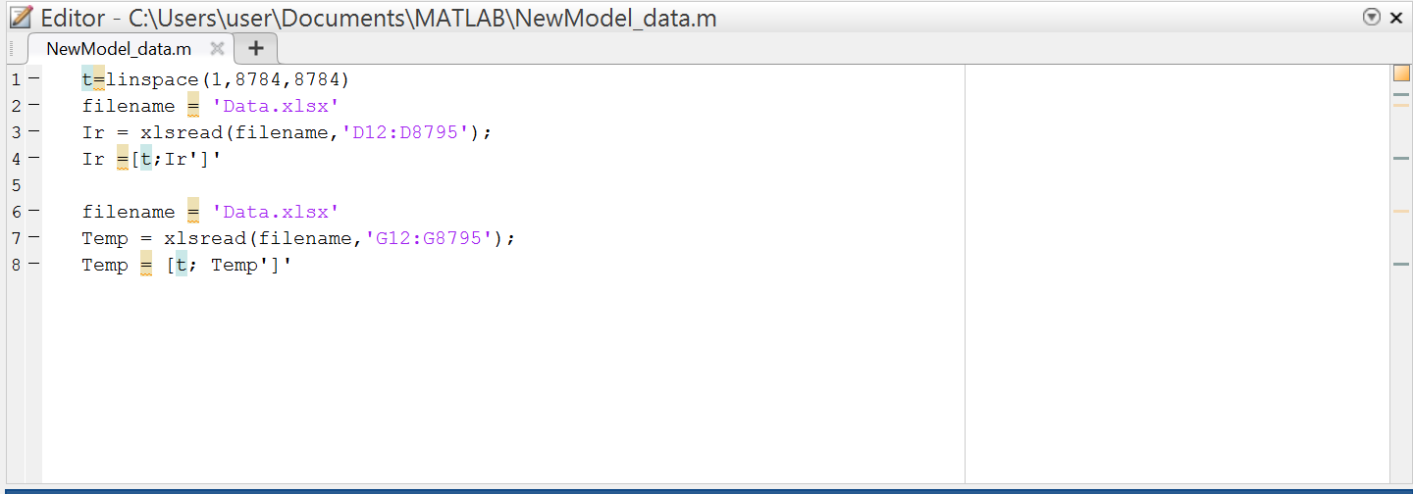
Fig. 1 - Data entry in MatLab
Further go to work in Simulink . To work with data, it is necessary to use the "From Workspace" block and enter the value of radiation and temperature ( Ir , Temp ) in the Data line .
Select the PV array in the library and connect it to the original Ir and Temp blocks .
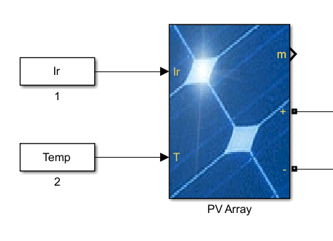
Fig. 2 - Solar panel unit
For example , in the parameter setting section (Fig. 3) , a solar panel of the type: SunPower SPR-X20-250- BLK was used. The number of parallel solar panels was 60pcs, and the modules connected via a serial channel - 10.
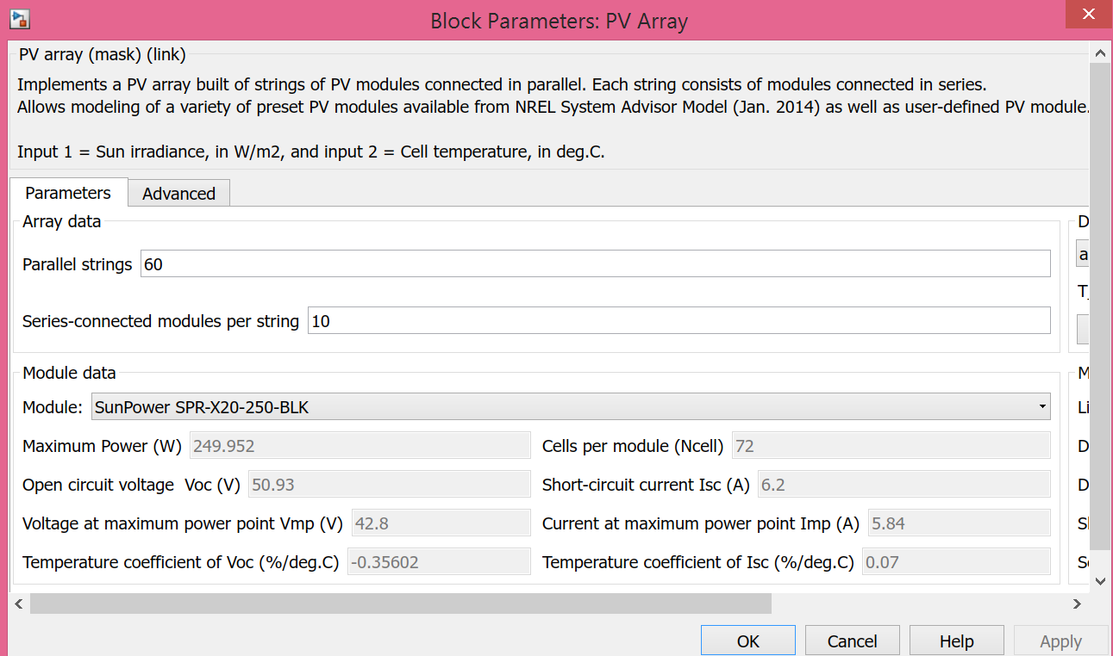
Fig . 3 - Solar Unit Parameters
Set the voltage source (Controlled Voltage Source ) of the DC voltage with the input voltage value equal to 42.8 V.
To obtain output values ​​with which you can later work, we install an ammeter and a voltmeter, as well as a Scope . Using the Scope block, you can see graphs of time versus voltage and current.
To find out the power that the solar panel generates, the values ​​obtained from the voltage and current measurement units are multiplied with each other using the " Product " block . The number of inputs is set to 2.
As a result, we got the generated power from solar panels expressed in constant values ​​(direct current) - the linear dependence of power on time. For further calculations, we need to convert the linear dependence into sinusoidally varying values.

- Inverter.
To convert direct current into an alternating voltage with a magnitude of change are used inverters. We implement a simple example of an inverter under operating conditions. For this we need to use an AC source - Controlled Current Source , to convert the graph into a sinusoidal relationship.
We will establish the coefficient of conversion of constant values ​​into variables equal to 0.98 with the help of the Gain block . Thus, we assume that P _{AC} = 0.98 * P _{DC} .
Next, to obtain the sinusoidal dependence, we need to establish an AC source Controlled Current Source . The values ​​at the exit from Gain divide , using the Divide block , with a constant value of voltage ( we set the Constant block to 230 ) . Among the inputs, in the Divide block, set * / .
The values ​​obtained at the previous stage must be divided, with the Divide block , with a constant value of 230 V , which is set in the Constant block . The obtained values ​​are used as an input signal for the Controlled Current Source block .
In block Controlled Current Source Sets the value of m is equal to 50 Hz frequency in Source Type select line AC, which corresponds to an alternating current source. After this, we successively connect plus current source to the ammeter, and in parallel with the voltmeter and add the blocks Scope . Connect in parallel to the circuit resistance equal to 1, it is intended to simulate the resistance of the system.
- Modeling of the electrical network (load).
Consumer (load) is represented as a voltage source (Controlled Voltage Source) s m with the active (R) and reactive (L) resistance, as well as a voltmeter and ammeter.
AC voltage source ( Controlled Voltage Source ) connect one of the inputs to a block that generates a sinusoidal signal. In the Sine Wave block, set the amplitude to 325, and the frequency to 2 * pi * 50.To obtain real data with a period of 20 ms , it is necessary to correctly select the data for generating a sinusoidal curve.
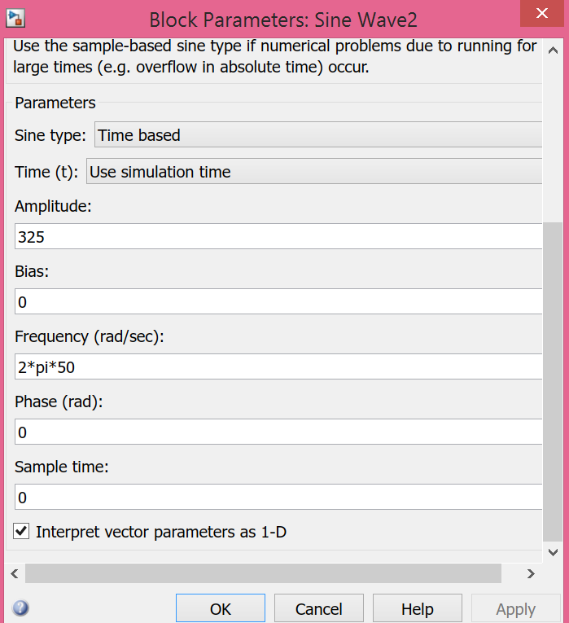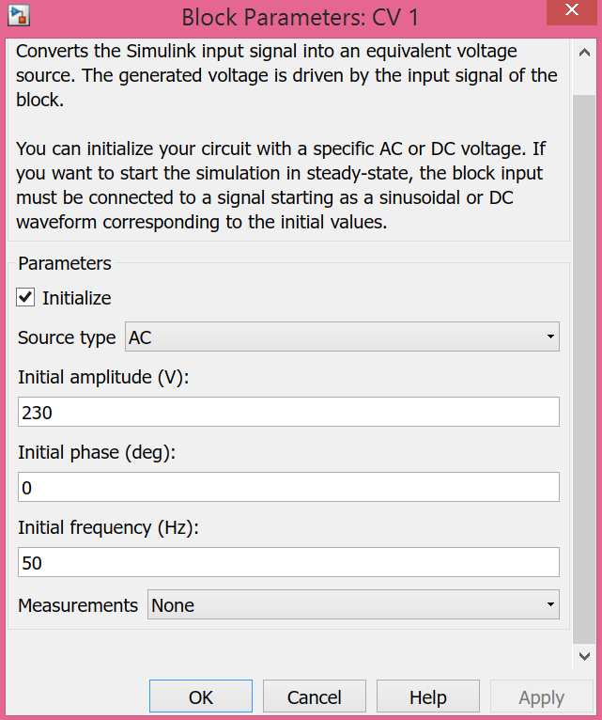
Fig. 4 - Parameters of a sinusoid and an alternating voltage source.

In the AC voltage block ( Controlled Voltage Source ) we take the amplitude equal to 230 V , the frequency is 50 Hz, and in the Source Type row select AC ( Figure 4 ) .
The output of the inverter is connected in series with the " Series RLC Branch" block ", in the Branch Type row select the parameter RL . In further calculations, by changing the parameters R and L , we can obtain the desired value of current and voltage for the consumer.
After the resistance block we set the ammeter and connect its output to the positive of the voltage source " + " . In parallel to the voltage source we connect a voltmeter. The minus of the voltage source is connected with the minus of the current source (the output of the inverter is " -" ).
The values of the output voltmeter and forth flushes us the desired value of the AC voltage of our energy system. The result should receive s Xia sinusoidal variation of voltage with a frequency of 50 Hz.
- Modeling of the accumulation system (batteries) .
In order to make the power system more independent and flexible, it is possible to establish a system of accumulation of excess power generation solar panels (batteries).
The installation of batteries will allow maneuvering the schedule of power consumption and choosing the optimal variant of power consumption by the object of housing stock. It is also possible to achieve an absolutely autonomous energy supply for the home, if this is necessary and expedient.
To connect the batteries correctly, you need to install one more inverter. We connect the values ​​of the alternating voltage in the power system (load) through the resistance to a constant current source.As an input signal, for a constant current source ( Controlled Current Source ) we use the Constant block and set the value to 24 A.
Acquiring P, as a result, the current and voltage must be multiplied together to determine the value of the power grid. To do this, we use the "Product" block , with two inputs for current and voltage.
Next, we need to convert the variable value of the power change into constant values, for this we divide our values ​​into the sinusoid used before. We use the Divide block with two inputs, resulting in a linear power dependence on time.
Find the values ​​of direct current, divide the power by a constant voltage value (assuming a voltage equal to 230 V). To do this, we also use blocks Divide and Constant .
The obtained values ​​of the current are used as the input signal of a constant current source. After that, we connect the resistance and ammeter to it, and in parallel - the voltmeter.
By the output of the inverter, the battery is connected in parallel and connected to the unit Demux, with a number of outputs equal to 3. We connect them with the Scope box, specifying the number of entries equal to three, of the n allows you to see the percentage of battery charge current and voltage on it.
Battery parameters , according to our model , and the power of the panels are:
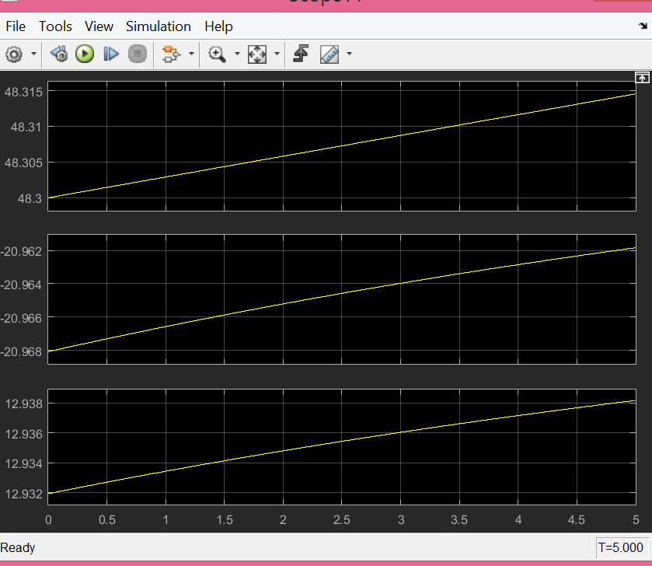
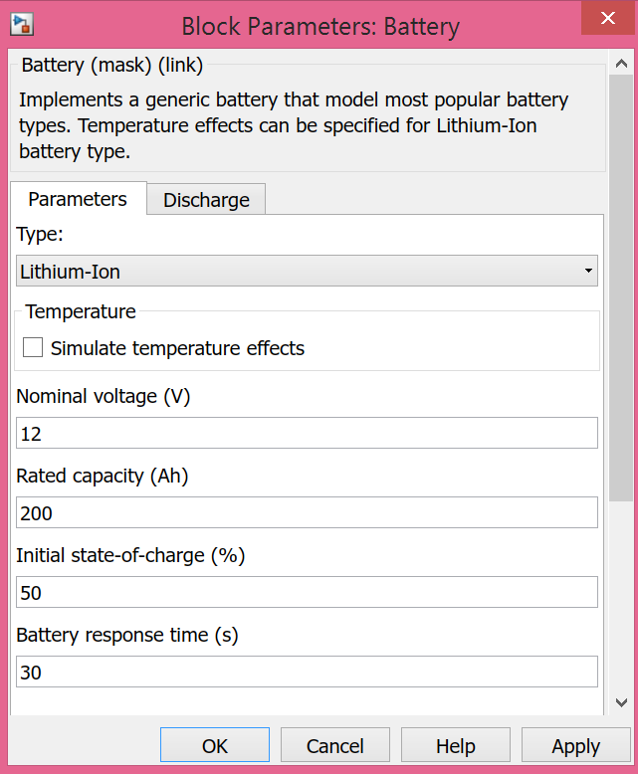

- General settings of the model.
The powergui block the you to choose one of these methods to solve your circuit :
- Continuous , which uses a variable-step solver from Simulink ®
- Ideal switching continuous
- Discretization of the Electric system for a solution at fixed time steps
- Phasor solution
The powergui block also opens tools for steadystate and simulation results analysis and for advanced parameter design .
You need the powergui block to simulate any Simulink model containing Simscape ™ Power Systems ™ Specialized Technology blocks . It stores the equivalent Simulink circuit that is the state-space equationsof the model .
For our model we use the block powergui with value Sample time equal to 5e-06 , and Simulation type : Discrete . Thus, you can achieve better results of calculation and modeling of the system.
Also set the Simulation stop time to 24, which corresponds to a simulation of the system's operation per day. Choosing this value is less, you can see a sinusoidal voltage change with a frequency of 50 Hz, and speed up the processing of data.

